**Ideation Phase Define the Problem Statements**

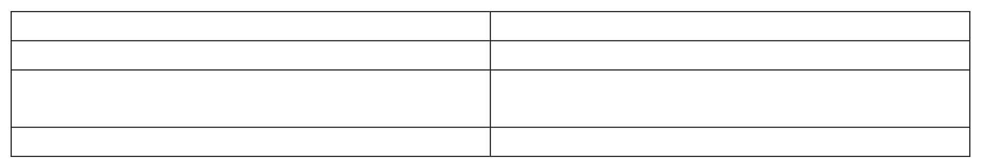

Date

Team ID

Project Name

Maximum Marks

2

marks

28

January

2025

LTVIP2025TMID59707

HOUSEHUNT:Finding your perfect rental house

**Customer Problem Statement Template:**

Defining the problem statement is a crucial step in understanding the core challenges faced by business users in this project. The primary objective is to analyze how product placement strategies influence sales performance, using Tableau for effective data visualization and decision-making support.

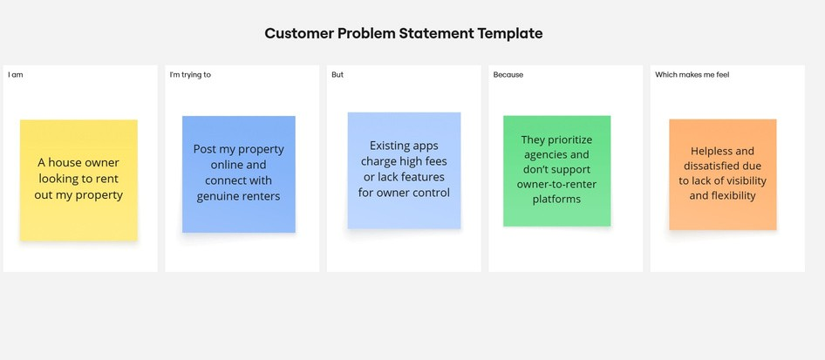The core problem in this project is that retail managers and analysts lack clear, visual insights to understand how product placement affects sales. Existing data is often scattered or non-interactive, making it difficult to make quick, informed decisions. This project aims to solve that by using Tableau to create interactive dashboards that reveal the sales impact of different product placements, helping users make smarter, data-driven decisions with confidence.

Problem Statement 1:**Tenants can't easily find suitable rentals due to poor filters and limited owner contact.**

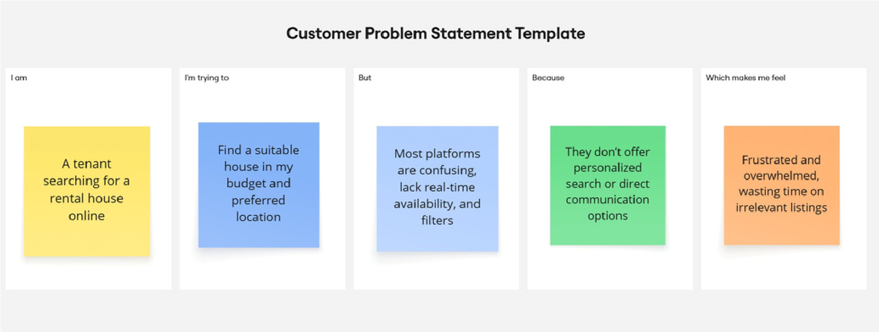

Problem Statement 2: **Owners struggle to rent out homes due to high fees and low visibility**.

|  |  |  |  |  |  |
| --- | --- | --- | --- | --- | --- |
| **No.** | **I am (Customer)** | **I’m trying to** | **But** | **Because** | **Which makes me feel** |
| **PS-1** | A tenant  searching for a  rental house  online | Find a suitable  house in my  budget and  preferred  location | Most platforms  are confusing,  lack real-time  availability, and  filters | They don’t offer  personalized  search or direct  communication  options | Frustrated and overwhelmed, wasting time on irrelevant listings |
| **PS-2** | A house owner looking to rent out my property | Post my property online and connect with genuine renters | Existing apps charge high fees or lack features for owner control | They prioritize agencies and don’t support owner-to-renter platforms | Helpless and  dissatisfied due  to lack of  visibility and  flexibility |